Name: ____________________

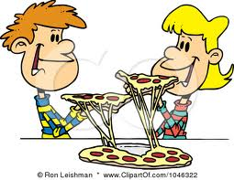

If everyone shares equally, who gets more pizza: a child sitting at a table where 4 children are sharing a medium pizza, or a child sitting at a table where 8 children are sharing a medium pizza?

Justify your thinking with pictures, numbers, or words.